34.5: a)
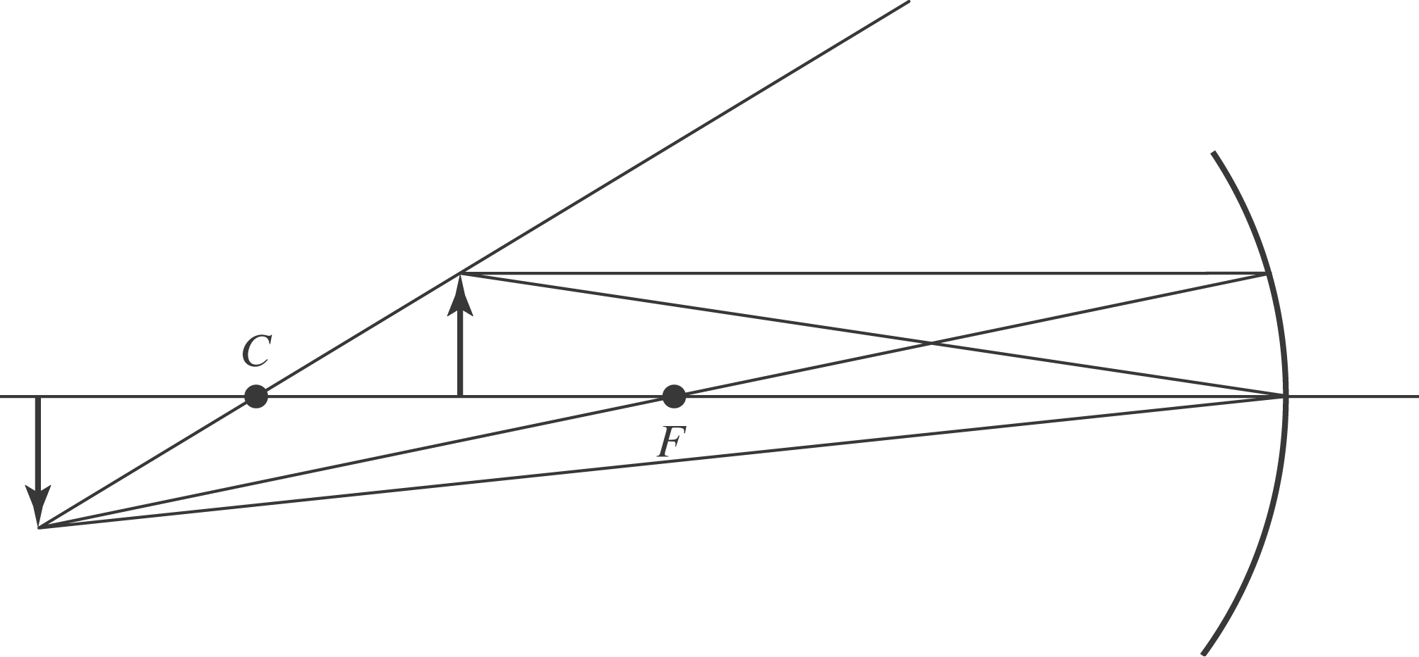

b) 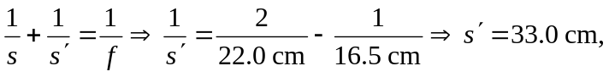to the left of the mirror.
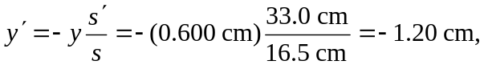and the image is inverted and real.

